

**DEPARTMENT OF COMPUTER SCIENCE AND DESIGN**

**ACADEMIC YEAR 2024-2025 ODD SEMESTER**



**CD23332**

**LAB MANUAL**

**SECOND YEAR**

**THIRD SEMESTER**

**2024- 2025**

**ODD SEMESTER**

|  |  |  |
| --- | --- | --- |
| **List of Experiments** | | |
| 1 | Design to teach mathematics to the children of 4-5 years age in school in Rural sector | |
| 2 | Design to help people to sell their handmade products in metro cities | |
| 3 | Design a social media website and chat | |
| 4 | Design a publication that support different languages | |
| 5 | Design a publication that tells comic stories | |
| 6 | Design an advertisement for mobile company | |
| 7 | Design an advertisement for any political party with images | |
| 8 | Design an advertisement for electronic products | |
| 9 | Design an advertisement for food products | |
| 10 | Design an interactive website for new institution | |
| 11 | Design a blog that publish educational post | |
| 12 | Design an interactive website for hospital management system | |
| 13 | Design an interactive website for food selling app | |
| **Requirements** | | |
| Hardware | | Intel i3 or AMD processor with 64-bit support;2 GHz or faster processor with SSE 4. or later- 8 GB RAM -Windows 10 64-it (version 1909)or later - 1.5 GB of GPU memory -4 GB of available hard-disk space |
| Software | | Figma, Adobe Photoshop, HTML and CSS |
| Operating System | | Windows |

**LAB PLAN**

**CD23332-DESIGN PROCESSES AND PERSPECTIVES LAB**

|  |  |  |
| --- | --- | --- |
| **Exercise no.** | **Exercise Name** | **Required Hours** |
| 1 | Design to teach mathematics to the children of 4-5 years age in school in Rural sector | 3 |
| 2 | Design to help people to sell their handmade products in metro cities | 6 |
| 3 | Design a social media website and chat | 3 |
| 4 | Design a publication that support different languages | 3 |
| 5 | Design a publication that tells comic stories | 3 |
| 6 | Design an advertisement for mobile company | 3 |
| 7 | Design an advertisement for any political party with images | 9 |
| 8 | Design an advertisement for electronic products | 6 |
| 9 | Design an advertisement for food products | 6 |
| 10 | Design an interactive website for new institution | 6 |
| 11 | Design a blog that publish educational post | 6 |
| 12 | Design an interactive website for hospital management system. | 3 |
| 13 | Design an interactive website for food selling app. | 3 |

**Course Outcomes (COs)**

**Course Name: Design Processes and Perspectives Course Code: CD19341**

|  |  |
| --- | --- |
| Outcome 1 | Understand the various graphic design thinking process and phases |
| Outcome 2 | Analyze and choose between various visual components |
| Outcome 3 | Designing and communicating visual components |
| Outcome 4 | Apply design concepts for media publishing and advertising |
| Outcome 5 | Create website using different design concepts |

# CO-PO –PSO matricesofcourse

|  |  |  |  |  |  |  |  |  |  |  |  |  |  |  |  |
| --- | --- | --- | --- | --- | --- | --- | --- | --- | --- | --- | --- | --- | --- | --- | --- |
| PO/PSO  CO | PO 1 | PO 2 | PO 3 | PO 4 | PO 5 | PO 6 | PO 7 | PO 8 | PO 9 | PO 10 | PO 11 | PO 12 | PSO 1 | PSO 2 | PSO 3 |
| CD19341.1 | 3 | 1 | 3 | 2 | 3 | 2 | 3 | 2 | 1 | 1 | 1 | 3 | 1 | 3 | 1 |
| CD19341.2 | 3 | - | 3 | - | 3 | - | - | - | - | - | 1 | 1 | 1 | 3 | 1 |
| CD19341.3 | 3 | 3 | 3 | 2 | 3 | - | - | - | - | - | - | 1 | 1 | 3 | 2 |
| CD19341.4 | 1 | 3 | 3 | 3 | 3 | 3 | 2 | 2 | 2 | 2 | 2 | 2 | 1 | 3 | 3 |
| CD19341.5 | 1 | 3 | 3 | 3 | 3 | 3 | 2 | 2 | 2 | 2 | 2 | 2 | 1 | 3 | 3 |
| Average | 2.2 | 2.0 | 3.0 | 2.0 | 3.0 | 1.6 | 1.4 | 1.0 | 1.0 | 1.0 | 1.2 | 1.8 | 1.0 | 3.0 | 2.0 |

Note: Enter correlation levels 1,2 or 3 as defined below:

1: Slight(Low) 2: Moderate(Medium) 3: Substantial(High) If there is no correlation, put “-“

**Expt. No.:1**

**Date:**

**Design to teach mathematics to the children of 4-5 years age in school in Rural sector**

**Aim:** To design a user interface for teaching mathematics to the children of 4-5 years age in school in the rural sector.

**Tools:** Figma, Photoshop

**Steps:**

1. Create a new background layer.
2. Create containers for placing images, icons and logos.
3. Gradient color panel has to be used.
4. Buttons and attractive fonts have been used.
5. Proper navigation should be done to move from one page to another.
6. Login page has to be included.

**Output:**

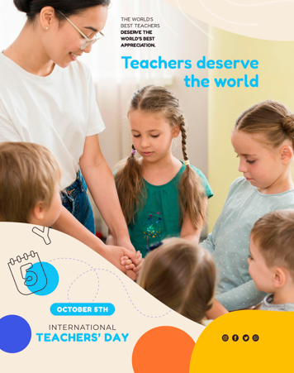

**Result:**

**The experiment aims to assess the impact of a hands-on, culturally relevant mathematics curriculum on improving basic math skills in 4-5-year-old children in rural schools.**

**Expt. No.:2**

**Date:**

**Design to help people to sell their handmade products in metro cities**

**AIM:** To Design an UI that can help people to sell their handmade products in metro cities

**Tools:** Figma, Photoshop

**Steps:**

1. Create a new background layer.
2. Create containers for placing images, icons and logos.
3. Gradient color panel has to be used.
4. Buttons and attractive fonts have been used.
5. Proper navigation should be done to move from one page to another.
6. Login page has to be included.

**Output:**

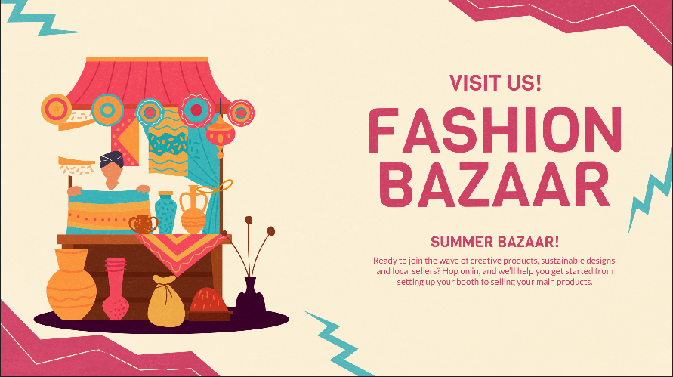

**Result:**

**The UI design successfully enables users to easily list, showcase, and sell their handmade products to a wider audience in metro cities, enhancing visibility and accessibility.**

**Expt. No.:3**

**Date:**

**Design a social media website and chat**

**Aim:** To design a user interface for teaching mathematics to the children of 4-5 years age in school in the rural sector.

**Tools:** Figma, Photoshop

**Steps:**

1. Create a new background layer.
2. Create containers for placing images, icons and logos
3. Gradient color panel has to be used
4. Buttons and attractive fonts have been used
5. Proper navigation should be done to move from one page to another
6. Login page has to be included

**Output:**

**Result:**

**The design of the social media website and chat platform effectively facilitates seamless user interaction, content sharing, and real-time communication.**

**Expt. No.:4**

**Date:**

**Design a publication that support different languages**

**Aim:** To design a publication that support different language

**Tools:** Adobe Photoshop

**Steps:**

1. Create a new background layer.
2. Create containers for placing images, icons and logos
3. Gradient color panel has to be used
4. Use different languages to display the content.
5. Use images that support the content.
6. Align white spaces between the contents.

**Output:**

**Result:**

**The publication design successfully supports multiple languages, offering an intuitive, accessible experience for diverse global audiences.**

**Expt. No.:5**

**Date:**

**Design a publication that tells comic stories**

**Aim:** To design a Publication That Tells Comic Stories

**Tools:**  Adobe Photoshop

**Steps:**

1. Create a new background layer.

2. Create containers for placing images, icons and logos

3. Gradient color panel has to be used.

4. Use different languages to display the content.

5. Use images that support the content.

6. Align white spaces between the contents.

**Output:**

**Result:**

**The comic publication design engages readers with vibrant visuals and compelling narratives, delivering an entertaining storytelling experience.**

**Expt. No.:6**

**Date:**

**Design an advertisement for mobile company**

**Aim:** To design an advertisement for mobile company

**Tools:**  Adobe Photoshop, Canva

**Steps:**

1. Create a new background layer.

2. Create containers for placing images, icons and logos

3. Gradient color panel has to be used

4. Images that support the context must be placed.

5. Written context must be emphasized.

6. Appropriate color palette must be used.

**Output:**

**Result:**

**The advertisement design effectively highlights the mobile company's key features, capturing attention with dynamic visuals and a clear, persuasive message.**

**Expt. No.:7**

**Date:**

**Design an advertisement for any political party with images**

**Aim:** To design an advertisement for any political party with images

**Tools:**  Adobe Photoshop, Canva.

**Steps:**

1. Create a new background layer.

2. Create containers for placing images, icons and logos.

3. Gradient color panel has to be used.

4. Images that support the context must be placed.

5. Written context must be emphasized.

6. Appropriate color palette must be used.

**Output:**

**Result:**

**The political party advertisement design uses impactful images and messaging to convey the party's vision, engaging voters and promoting key campaign promises.**

**Expt. No.:8**

**Date:**

**Design an advertisement for electronic products**

**Aim:** To design an advertisement for electronic products

**Tools:**  Adobe Photoshop, Canva

**Steps:**

1. Create a new background layer.

2. Create containers for placing images, icons and logos.

3. Gradient color panel has to be used .

4. Images that support the context must be placed.

5. Written context must be emphasized.

6. Appropriate color palette must be used.

**Output:**

**Result:**

**The advertisement design showcases electronic products with sleek visuals and compelling features, highlighting their innovation and value to attract tech-savvy consumers.**

**Expt. No.:9**

**Date:**

**Design an advertisement for food products**

**Aim:** To design an advertisement for food products

**Tools:**  Adobe Photoshop, Canva

**Steps:**

1. Create a new background layer.

2. Create containers for placing images, icons and logos.

3. Gradient color panel has to be used .

4. Images that support the context must be placed.

5. Written context must be emphasized.

6. Appropriate color palette must be used.

**Output:**

**Result:**

**The food product advertisement design appetizes viewers with vibrant imagery and enticing descriptions, emphasizing freshness, quality, and taste.**

**Expt. No.:10**

**Date:**

**Design an interactive website for new institution**

**Aim:** To design interactive website for new institution

**Tools:** HTML, CSS

**Steps:**

1. Create a document of type HTML.

2. Craft a style sheet for better design.

3. Include the link of the stylesheet to the HTML file.

4. Assign a title for each page.

5. Add the required styles and attributes for the HTML tags.

6. Include action tag to navigate from one page to another.

**Output:**

**1 <!DOCTYPE html>**

**2- <html lang="en">**

**3- <head>**

**4**

**5**

**6**

**10**

**11**

**13**

**14**

**15**

**<meta charset="UTF-8">**

**<meta name="viewport" content="width=device-width, initial-scale=1.0"> <title>Institution Name</title>**

**<style>**

**body { font-family: Arial, sans-serif; margin: 0; padding: 0; }**

**header, footer { background: #0044cc; color: white; text-align: center; padding: 10px; } nav (text-align: center; padding: 10px; background: #f1f1f1; }**

**nav a {margin:**

**10px; color: #0044cc; text-decoration: none; }**

**section { padding: 20px; }**

**h2 { color: #0044cc;}**

**form input, form textarea { width: 100%; margin: 5px 0; padding: 8px; } </style>**

**16 </head>**

**17 <body>**

**18**

**19- <header>**

**20**

**21**

**<h1>Institution Name</h1>**

**<p>Welcome to Our Institution</p>**

**22 </header>**

**23**

**24- <nav>**

**25**

**26**

**27**

**28**

**29**

**30**

**<a href="#about">About Us</a>**

**<a href="#courses">Courses</a> <a href="#admissions">Admissions</a> <a href="#contact">Contact</a>**

**</nav>**

**31 <section id="about">**

**32**

**33**

**<h2>About Us</h2>**

**<p>We are dedicated to providing quality education to our students.</p> 34 </section>**

**35**

**36 <section id-"courses">**

**37 38**

**<h2>Courses</h2>**

**<p>Explore our wide range of courses to find the right one for you.</p> 29 </section>**

**40**

**41**

**42**

**43**

**<section id-"admissions">**

**<h2>Admissions</h2>**

**<p>Join us to start your journey toward success. Apply now!</p>**

**44 </section>**

**45**

**46**

**47**

**48-**

**49**

**50**

**51**

**52**

**53**

**<section id="contact">**

**<h2>Contact Us</h2>**

**<form>**

**<input type="text" placeholder-"Your Name" required>**

**<input type="email" placeholder="Your Email" required>**

**<textarea rows="4" placeholder-"Your Message" required></textarea> <button type="submit">Send Message</button>**

**</form>**

**54 </section>**

**55**

**56 <footer>**

**57**

**<p>&copy; 2024 Institution Name</p>**

**58 </footer>**

**59**

**60 </body>**

**61 </html>**

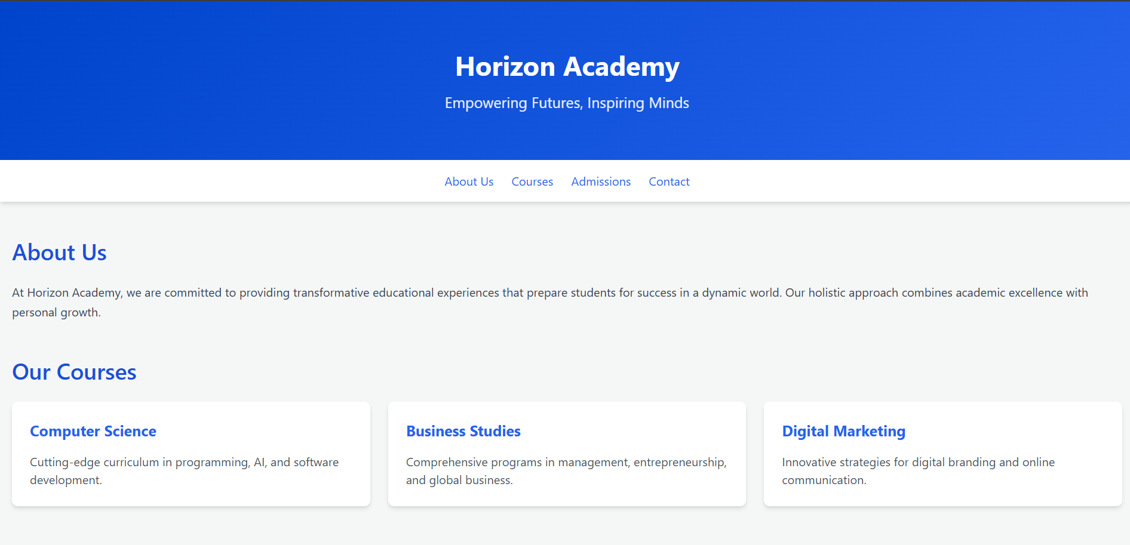

**Result:**

**The interactive website design for the new institution offers a user-friendly experience with engaging content, easy navigation, and essential information for prospective students.**

**Expt. No.:11**

**Date:**

**Design A Blog That Publish Educational Post**

**Aim:** To design a blog that publishes educational post

**Tools:** HTML, CSS

**Steps:**

1. Create a document of type HTML.

2. Craft a style sheet for better design.

3. Include the link of the stylesheet to the HTML file.

4. Assign a title for each page.

5. Add the required styles and attributes for the HTML tags.

6. Include action tag to navigate from one page to another.

**Output:**

**<!DOCTYPE html>**

**<html lang="en">**

**<head>**

**<meta charset="UTF-8">**

**<meta name="viewport" content="width=device-width, initial-scale=1.0">**

**<title>Educational Blog</title>**

**<link rel="stylesheet" href="styles.css">**

**</head>**

**<body>**

**<header>**

**<h1>Welcome to the Educational Blog</h1>**

**<nav>**

**<ul>**

**<li><a href="#home">Home</a></li>**

**<li><a href="#about">About</a></li>**

**<li><a href="#posts">Posts</a></li>**

**<li><a href="#contact">Contact</a></li>**

**</ul>**

**</nav>**

**</header>**

**<main>**

**<section id="posts">**

**<article>**

**<h2>Understanding Photosynthesis</h2>**

**<p>Photosynthesis is the process by which green plants and some other organisms use sunlight to synthesize foods with the help of chlorophyll. This process converts light energy into chemical energy.</p>**

**<p><em>Published on: October 1, 2023</em></p>**

**</article>**

**<article>**

**<h2>The Importance of Mathematics in Daily Life</h2>**

**<p>Mathematics is not just a subject; it is a way of thinking. It helps us solve problems, make decisions, and understand the world around us.</p>**

**<p><em>Published on: October 5, 2023</em></p>**

**</article>**

**<article>**

**<h2>The Basics of Computer Programming</h2>**

**<p>Computer programming is the process of designing and building executable computer software to accomplish a specific task. It involves writing code in various programming languages.</p>**

**<p><em>Published on: October 10, 2023</em></p>**

**</article>**

**</section>**

**</main>**

**<footer>**

**<p>&copy; 2023 Educational Blog. All rights reserved.</p>**

**</footer>**

**</body>**

**</html>**

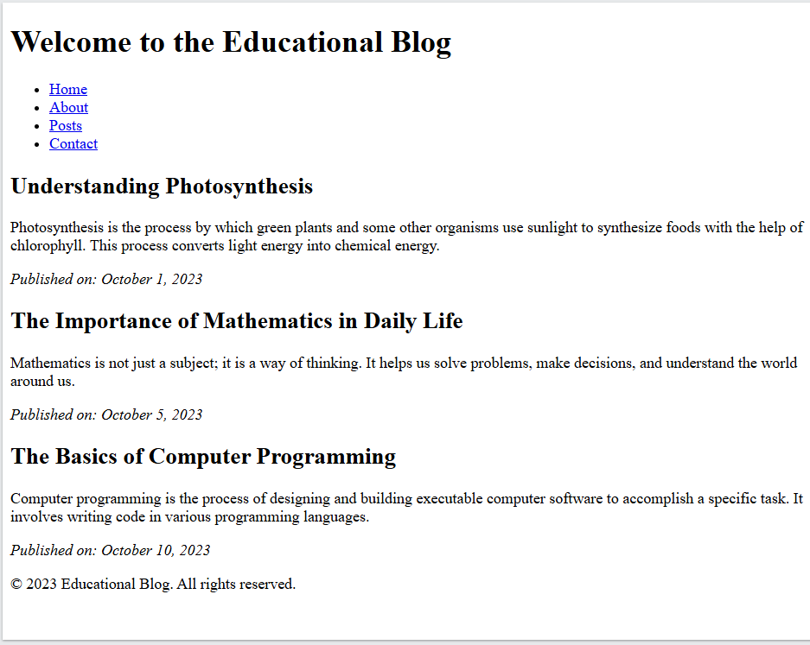

**Result:**

**The blog design effectively organizes and presents educational content with a clean, intuitive layout, fostering easy reading and engagement.**

**Expt. No.:12**

**Date:**

**Design An Interactive Website For Hospital Management System**

**Aim:** To design interactive website for hospital management system

**Tools:** HTML, CSS

**Steps:**

1. Create a document of type HTML.

2. Craft a style sheet for better design.

3. Include the link of the stylesheet to the HTML file.

4. Assign a title for each page.

5. Add the required styles and attributes for the HTML tags.

6. Include action tag to navigate from one page to another.

**Output:**

**<!DOCTYPE html>**

**<html lang="en">**

**<head>**

**<meta charset="UTF-8">**

**<meta name="viewport" content="width=device-width, initial-scale=1.0">**

**<title>Hospital Management System</title>**

**<link rel="stylesheet" href="styles.css">**

**</head>**

**<body>**

**<header>**

**<h1>Hospital Management System</h1>**

**<nav>**

**<ul>**

**<li><a href="#home">Home</a></li>**

**<li><a href="#patients">Patients</a></li>**

**<li><a href="#appointments">Appointments</a></li>**

**<li><a href="#contact">Contact</a></li>**

**</ul>**

**</nav>**

**</header>**

**<main>**

**<section id="home">**

**<h2>Welcome to Our Hospital</h2>**

**<p>Your health is our priority. Use our system to manage your health records, appointments, and more.</p>**

**</section>**

**<section id="patients">**

**<h2>Patient Registration</h2>**

**<form>**

**<label for="name">Full Name:</label>**

**<input type="text" id="name" name="name" required>**

**<label for="age">Age:</label>**

**<input type="number" id="age" name="age" required>**

**<label for="gender">Gender:</label>**

**<select id="gender" name="gender">**

**<option value="male">Male</option>**

**<option value="female">Female</option>**

**<option value="other">Other</option>**

**</select>**

**<label for="contact">Contact Number:</label>**

**<input type="tel" id="contact" name="contact" required>**

**<input type="submit" value="Register Patient">**

**</form>**

**</section>**

**<section id="appointments">**

**<h2>Appointment Scheduling</h2>**

**<form>**

**<label for="patient">Select Patient:</label>**

**<input type="text" id="patient" name="patient" required>**

**<label for="date">Appointment Date:</label>**

**<input type="date" id="date" name="date" required>**

**<label for="time">Appointment Time:</label>**

**<input type="time" id="time" name="time" required>**

**<input type="submit" value="Schedule Appointment">**

**</form>**

**</section>**

**</main>**

**<footer>**

**<p>&copy; 2023 Hospital Management System. All rights reserved.</p>**

**</footer>**

**</body>**

**</html>**

**Result:**

**The interactive hospital management system website design streamlines patient registration, appointment scheduling, and medical record access, ensuring efficient and user-friendly navigation for both staff and patients.**

**Expt. No.:13**

**Date:**

**Design An Interactive Website For Food Selling App**

**Aim:** To design a interactive website for food selling app

**Tools:** HTML, CSS

**Steps:**

1. Create a document of type HTML.

2. Craft a style sheet for better design.

3. Include the link of the stylesheet to the HTML file.

4. Assign a title for each page.

5. Add the required styles and attributes for the HTML tags.

6. Include action tag to navigate from one page to another.

**Output:**

**<!DOCTYPE html>**

**<html lang="en">**

**<head>**

**<meta charset="UTF-8">**

**<meta name="viewport" content="width=device-width, initial-scale=1.0">**

**<title>Food Selling App</title>**

**<link rel="stylesheet" href="styles.css">**

**</head>**

**<body>**

**<header>**

**<h1>Foodie - Your Favorite Food Delivery</h1>**

**<nav>**

**<ul>**

**<li><a href="#home">Home</a></li>**

**<li><a href="#menu">Menu</a></li>**

**<li><a href="#about">About Us</a></li>**

**<li><a href="#contact">Contact</a></li>**

**</ul>**

**</nav>**

**</header>**

**<main>**

**<section id="home">**

**<h2>Welcome to Foodie</h2>**

**<p>Your favorite meals delivered to your doorstep. Explore our delicious menu!</p>**

**</section>**

**<section id="menu">**

**<h2>Our Menu</h2>**

**<div class="food-item">**

**<h3>Pizza</h3>**

**<p>Delicious cheese and tomato pizza topped with fresh basil.</p>**

**<span class="price">$12.99</span>**

**<button>Add to Cart</button>**

**</div>**

**<div class="food-item">**

**<h3>Burger</h3>**

**<p>Juicy beef burger with lettuce, tomato, and cheese.</p>**

**<span class="price">$9.99</span>**

**<button>Add to Cart</button>**

**</div>**

**<div class="food-item">**

**<h3>Pasta</h3>**

**<p>Creamy Alfredo pasta with grilled chicken and broccoli.</p>**

**<span class="price">$11.99</span>**

**<button>Add to Cart</button>**

**</div>**

**<div class="food-item">**

**<h3>Salad</h3>**

**<p>Fresh garden salad with a variety of vegetables.</p>**

**<span class="price">$7.99</span>**

**<button>Add to Cart</button>**

**</div>**

**</section>**

**<section id="about">**

**<h2>About Us</h2>**

**<p>We are dedicated to delivering the best food experience right to your door. Our chefs use only the freshest ingredients to create mouth-watering dishes.</p>**

**</section>**

**<section id="contact">**

**<h2>Contact Us</h2>**

**<p>If you have any questions, feel free to reach out!</p>**

**<form>**

**<label for="name">Name:</label>**

**<input type="text" id="name" name="name" required>**

**<label for="email">Email:</label>**

**<input type="email" id="email" name="email" required>**

**<label for="message">Message:</label>**

**<textarea id="message" name="message" required></textarea>**

**<input type="submit" value="Send Message">**

**</form>**

**</section>**

**</main>**

**<footer>**

**<p>&copy; 2023 Foodie. All rights reserved.</p>**

**</footer>**

**</body>**

**</html>**

**Result:**

**The interactive website design for the food-selling app offers an intuitive interface for browsing, ordering, and tracking deliveries, enhancing the user experience with seamless navigation and vibrant visuals.**